**Inventory Management App using Salesforce**

**A PROJECT REPORT**

**Surbhi Mittal**

**University Roll No- 1900290149098**

**Submitted in partial fulfillment of the**

**Requirements for the Degree of**

**MASTER OF COMPUTER APPLICATIONS**

**Under the Supervision of**

**Cognizant Technology.**



**Submitted to:**

**Department Of Computer Applications**

**KIET Group of Institutions, Ghaziabad**

**Uttar Pradesh-201206**

**(JUNE 2021)**

**CERTIFICATE**

Certified that **Surbhi Mittal (University Roll No. 1900290149098)** have carried out the project work having “**Inventory Management app with Salesforce**” for Master of Computer Applications from Dr. A.P.J. Abdul Kalam Technical University (AKTU**)** (formerly UPTU), Technical University, Lucknow under my supervision. The project report embodies original work, and studies are carried out by the student himself/herself and the contents of the project report do not form the basis for the award of any other degree to the candidate or to anybody else from this or any other University/Institution.

**Date:**

**Surbhi Mittal**

**University Roll No. 1900290149098**

This is to certify that the above statement made by the candidate is correct to the best of my knowledge.

Date:

**______________**

**Signature of Internal Examiner Signature of External Examiner**

**Dr. Ajay Kr. Shrivastava**

**Head, Department of Computer Applications**

**KIET Group of Institutions, Ghaziabad**

# Abstract

Salesforce is a cloud-based customer relationship management (CRM) software that accelerates business relationships and can transform the working lives of the team. Marc Benioff developed it in the late 1990s and now it has been announced as the world's most innovative company for six consecutive years by Forbes Magazine. Unlike traditional CRM software, Salesforce is an internet service. It is available with just a sign-up and logs in through a browser, and it is immediately available. It is based on cloud computing, where the customers, without the need of installing any traditional software, can access the cloud, i.e., through the internet, for their business needs.

Inventory Management (IM) is the method of controlling and supervising the storage, utilization and ordering of components that an organization can track of their items it sells. It is the act of controlling and administering the quantities of products in the sale. For a business, an inventory is the main asset which represents an investment by the owner until the item is sold .

To demonstrate its functionalities of Salesforce, I created an application for inventory management. Here, In the inventory management, there are two parts: one is administration part, and another part is customer portal. The administrator manages the inventory and store operations, and the customer buys the products in the inventory through customer portal.

# Table of Contents

Abstract ..........................................................................................................................4

Chapter 1: Introduction to Cloud Computing .................................................................7

1.1 Introduction to Cloud Computing ................................................................7 1.2 Service Models of Cloud Computing .........................................................8

Chapter 2: Salesforce Basic ..........................................................................................10

2.1 Introduction to Salesforce .........................................................................10

2.2 The architecture of Salesforce ....................................................................10

2.3 Salesforce Multiple View Controller ........................................................11

2.4 Salesforce Versions ....................................................................................12

2.5 System Overview ......................................................................................13

2.6 Technologies of Salesforce .......................................................................14

2.7 Benefits of Using Salesforce ......................................................................15

Chapter 3: Inventory Management ...............................................................................17

3.1 Inventory Management ..............................................................................18

3.2 Development Area .....................................................................................18

3.2.1 Custom Apps ................................................................................18

3.2.2 Objects ..........................................................................................19

3.2.3 Fields ............................................................................................19

3.2.4 Relationships ................................................................................20 3.2.5 Tabs ..............................................................................................22 3.2.6 Securing and Sharing Data ...........................................................23 3.2.7 Page Layouts ................................................................................23

3.2.8 Visual Force .................................................................................24

3.2.9 Apex .............................................................................................24

3.2.10 Chatter ..........................................................................................24

3.2.11 Reports and Dashboards ...............................................................25

Chapter 4: Functionalities .............................................................................................26

4.1 Inventory Administration ............................................................................26

4.2 Customer Portal ...........................................................................................35

Appendix .......................................................................................................................45

References .....................................................................................................................51

## List of Figures

Figure 1: Cloud Computing ............................................................................................7

Figure 2: Service Models of Cloud Computing ..............................................................9

Figure 3: Service Models ................................................................................................9

Figure 4: Multi-tenancy.................................................................................................10

Figure 5: Salesforce MVC ............................................................................................11

Figure 6: Different Versions of Salesforce ...................................................................12

Figure 7: Salesforce Mobile App ..................................................................................13

Figure 8: Benefits of Salesforce ....................................................................................16

Figure 9: Inventory Management System .....................................................................17

Figure 11: An example of a Master-Detail relationship................................................21

Figure 12: Relationships between objects .....................................................................22

Figure 13: Schema of Inventory Administrator ............................................................26

Figure 14: Product Approval Process ..........................................................................32

Figure 15: Workflow of Customer Portal .....................................................................35

# Chapter 1: Cloud Computing

Cloud computing is usually defined as storing and managing the data over the cloud, rather than a local server. Cloud computing is easy to understand. All applications are developed and run in the web browser. Using the internet connection, users and developers will have access to whole applications thus eliminating the complexity and overhead of the maintain environment.

Unlike traditional business applications which are complicated, expensive and need experts to install, run, update and secure, cloud computing can be accessed anywhere with an online connection. In traditional systems, the entire infrastructure must work together. For such type of seamless interaction, and for the smooth run of the system, a constant maintenance is always required. With cloud computing, there is no necessity to invest money in acquiring and supporting hardware and software infrastructure, thus decreasing the potential cost for users and developers.

The main impact of cloud computing is on the responsiveness of IT systems. With the cloud computing environment, we can add users and developers instantly, and the applications can be deployed rapidly into the cloud which reduces the user request response time. As the complexity of the of the internal systems is removed, the organization can speed up the entire IT process .

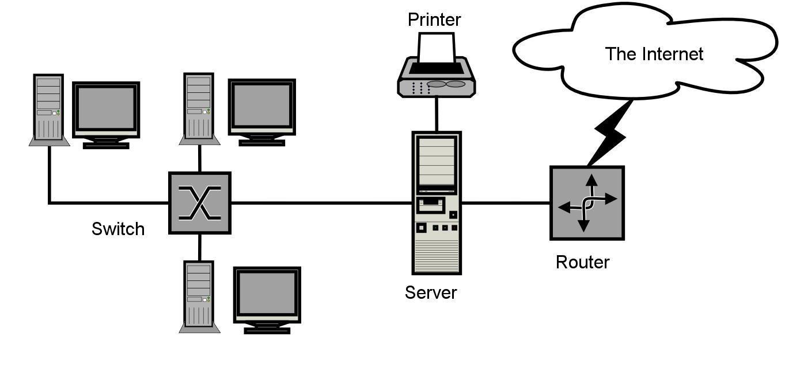

**Figure 1: Cloud Computing**

## 1.1 Service Models of Cloud Computing

### 1.11 Software as a Service (SaaS)

The end user can access the application which is developed by the provider on a cloud framework. The developed applications are available from different customer devices through interfaces like a web program or a program interface. Cloud infrastructure, servers, networks, storage and operating systems cannot be managed or controlled by the customer .

Cloud application services represent the increasing cloud market. Software as a service utilizes the internet to deploy the applications overseen by the vendor and whose interface will be able to access on the customer side. Many of the applications developed using SaaS will run in a web browser by using some plugins. There will not be need of any download or establishments.

The major applications which are developed using SaaS are healthcare related applications, client relationship administrations, incorporate email, and collaboration. Some of the costly ventures which are not able to considered as software vendors started using SaaS to get the upper hand and gain income.

### 1.12 Platform as a Service(PaaS)

The Client can deploy onto the cloud infrastructure developed by the customers with the help of libraries, tools, services and the programming languages which are supported by the client. The underlying infrastructure of cloud and storage, servers, network or operating systems cannot be managed or controlled by the Customer.

Cloud platform services can be utilized for applications and their advancements when cloud segments are given to programming. Developers can be able to pick the structure using PaaS where the applications can be expanded to create or modify. The testing and deployment of applications become easy and fast if the PaaS is used .

Enterprise PaaS gives a self-service portal to programming engineers for overseeing computing infrastructure from information technology operations. Scalability, Software as a service enablement and multi-occupancy can be acquired by the applications using PaaS. The coding fundamental measure will be decreased for the enterprises using PaaS and the application will be converted to a hybrid model.

### 1.13 Infrastructure as a Service (IaaS)

The customer can arrange systems, storage, processing and other essential computing resources in which the client can run and send arbitrary software like applications and operating systems. The hidden cloud infrastructure is not controlled or overseen by the customer but rather he can control over operating systems, storage, servers and network.

Cloud infrastructure services, referred to as IaaS, are models beneficial for overseeing and observing remote data center frameworks such as organizing, processing, stockpiling and networking services. With the help of IaaS, clients will get utility billing and power benefits.

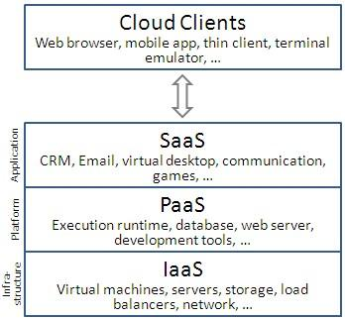

### Figure 2: Service Models of Cloud Computing

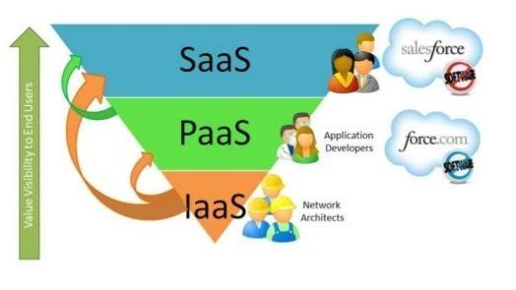

**Figure 3: Service Models**

# Chapter 2: Salesforce

## 2.1 Introduction to Salesforce

Salesforce is one of the world's prime cloud computing companies and number one on-demand customer relationship management(CRM). Salesforce does not need any software installation or hardware or any infrastructure like servers. All we need to access Salesforce is the internet. This empowers even the most non-techie individuals to be able to use the system and configure it as per their needs.

Established as Salesforce.com(SFDC) and its customer relationship management (CRM) service and then divided into different sectors like sales cloud, service cloud, community cloud, analytics cloud, data cloud, marketing cloud, app cloud, and so on.

Since Salesforce coordinates well with all the platforms and supports all major OS and mobile devices, it is anything but difficult to utilize Salesforce outside of the workplace, thus helps to improve productivity.

## 2.2 The Architecture of Salesforce

Salesforce has a multi-tenant Architecture. Multi-tenancy is the fundamental technology utilized as a part of the cloud to share its resources safely and cost effectively. It's much the same as bank services where various tenants cost-efficiently share a common infrastructure yet safely and with most protection from other tenants. A cloud utilizes multi-tenant infrastructure to share its assets safely among different applications and occupants (organizations, associations, and so on) that use the cloud. Some clouds utilize virtualization-based architecture to confine occupants; others utilize custom software architecture to take care of business. The multi-tenant outline of a cloud service can dramatically affect the application delivery and the profitability of IT organization.

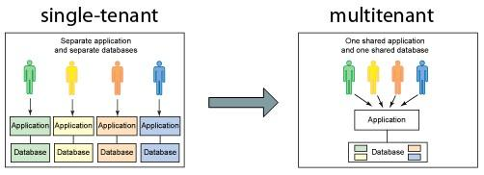

**Figure 4: Multi-Tenancy**

## 2.3 Salesforce Multiple View Controller (MVC)

MVC is a design pattern which separates business logic from interface logic i.e. it separates the graphical interface displayed to the user with the code that manages the user action**.**

In Salesforce, using SFDC visual force, we can write VIEW pages which are very similar to java servlets page(JSP) pages. Each visualforce(VF) page is corelated with a controller. The controller and model classes can be written using Apex language. In SFDC, controller part comprises of workflows, triggers, Apex classes and model layer comprises of fields, relationships, objects and View layer comprises of Tabs, page layouts, VF pages.

SFDC MVC mainly consists of three modules namely Model, View and Controller.

1. Model: Here we represent what schema and data the Salesforce used for the system representation and Sobjects are a model, as every entity is mapped to some subject in Salesforce.
2. View: Here we represent how data and schema and visual force are used to present data to users.
3. Controller: Here we use controllers and interface actions to perform actions when the user interacts with visual force

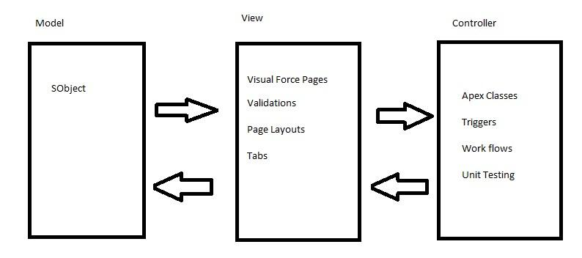

**Figure 5: Salesforce MVC**

## 2.4 Different editions of Salesforce.

Salesforce offers different editions of its products and services depending on business needs.

1)Professional Edition: This edition offers full CRM functionality.

2)Enterprise Edition: This edition offers advanced CRM customization and administration tools along with functionalities of Professional edition.

3)Unlimited Edition: Along with functionalities offered by Enterprise Edition, Unlimited Edition even offers full mobile access, premier support, unlimited custom apps and more.

4)Developer Edition: This edition allows developers to extend the Salesforce system, integration with other applications and develop new applications and tools.

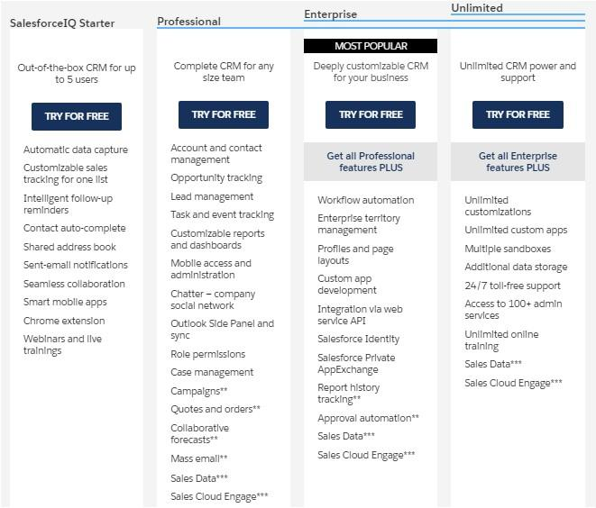

**Figure 6: Different Versions of Salesforce**

## 2.5 System Overview

Salesforce.com allows administrators to configure and design systems for complex implementations. Salesforce combines the power of configuration and custom development in its platform i.e. Force.com Platform. This platform user can make use of custom code, workflows rules, approval processes to implement their business logic and they can integrate the data with other applications, generate reports and do the analytics within no time. The Salesforce CRM model is used in organizations for interactions like emails, meetings, events with customers and also for prospects like sales, marketing, and support.

With Force.com, we can run business in the mobile using the Salesforce1 app. We can build and optimize the apps for mobile using HTML 5 and UI framework and it supports all devices with just one code base [5]. Salesforce1 downloadable app can be installed from the App store or Google play on a mobile device.

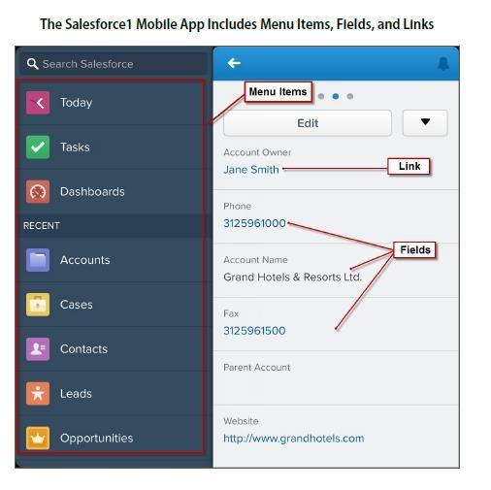

### Figure 7: Salesforce Mobile App 1

Salesforce even has an app marketplace called AppExchange where we can find pre-built business applications. AppExchange offers thousands of verified and secured apps built by others or we can develop our own app and sell it here. It’s quite similar to the App store and the play store [1].

Due to its ease of access, ease of use, minimum licensing/proprietary issues, and per user cost, Salesforce becomes a power system from small to large scale industries**.**

## 2.6 Technologies of Salesforce

### 1) Apex

Salesforce has a programming language called Apex. It is a case-insensitive, mostly typed object-oriented programming language with syntax identical Java with curly brackets and dotnotation syntax. Apex is used to run programs and procedure in Force.com such as links, buttons, record insertion and so on with visual force custom controllers.

### 2) Visualforce

Visualforce(VF) is a framework for the Force.com platform with tag-based markup language identical to HTML. With the help of Visualforce, custom pages can be created for mobile apps and desktops with the help of with other front-end technologies like HTML, CSS, jquery, and JavaScript. With the Visualforce standard and custom controller features, we can build our own business logic in Apex.

### 3) Lighting

Lightning is a component-based framework for the Salesforce1 mobile app which is built on an open source Aura framework. With the lighting framework, responsive applications can be built easily. The apps build on the Lighting framework is sold or brought on AppExchange.

Lightning App builder for Salesforce is a tool for quick application advancement of responsive web interfaces. This interface takes into account distinctive screens to be assembled given lightning segments. This can be layouts as formats for records or particular applications .

## 2.7 Benefits of Using Salesforce [6]

### 1) Invest in innovation, not infrastructure

With Salesforce, we can focus on business rather than the back end as Salesforce add new features and automatic upgrades three times a year. These boundary-pushing work made Salesforce one of Forbes’ Most Innovative Companies.

### 2) Don’t stress about the data security

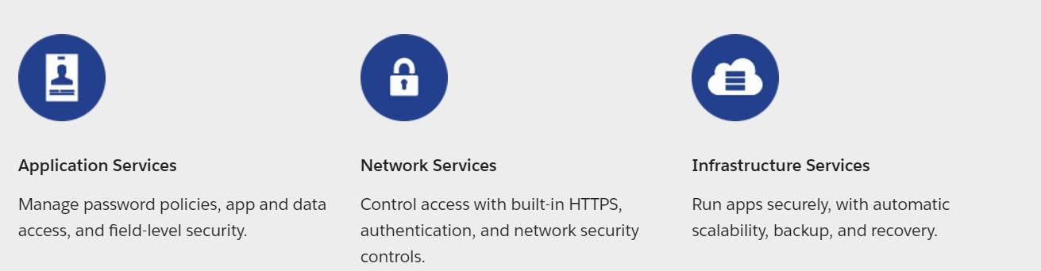

### 3) Make Salesforce work the way we want

Salesforce can be customized to the core to be more agile and productive and the apps can be developed with interfaces with point and click to high-end platforms.

### 4) With AppExchange, find Prebuilt applications in minutes

With industry-specific third party apps, Salesforce can be spread to every division and corporation. These apps are installed by millions of people and are reviewed by thousands. So with trust on the apps, we can focus on extending the business.

### 5) Work on one platform where everything works together

With Salesforce APIs, core technologies and third party tools, we can connect and manage data from any system and from anywhere.

Salesforce works in Desktop, Mobile Devices, and iPad too

Salesforce even have:

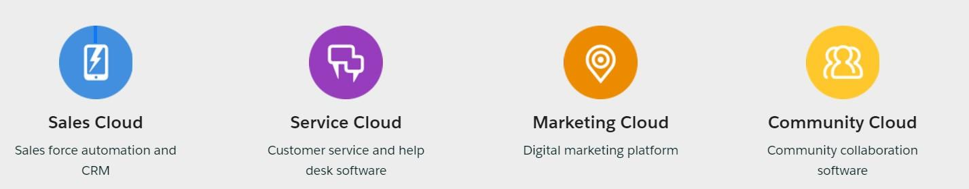

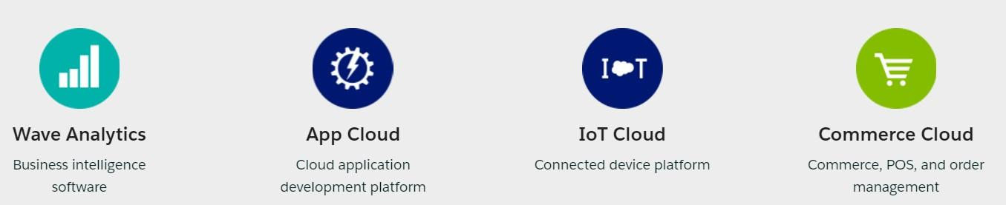

**Figure 8: Benefits of Salesforce**

## Chapter 3: The Inventory Management

### 3.1 The Inventory Management

Inventory Management is the process of arranging, storing and ordering the items in the inventory. It is also the process of controlling and observing the products that are finished and available for sale. For a business, an inventory is the main asset which represents an investment by the owner until the item is sold.

Inventory Management helps us to provide production of an item, its sales and provides a service level for the customer at low cost. The largest item for some of the companies is their inventories. If there is any problem with the inventory, then it will lead to the failure of the business. So we have to manage the items in the inventory very carefully.

Inventory control helps in reducing the inventory cost by increasing the chance of providing the product promptly to the customer. It is one of the parts of the Inventory Management.

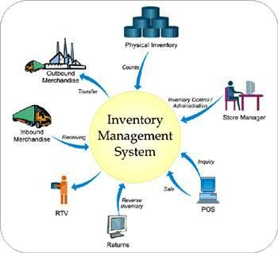

**Figure 9: Inventory Management System**

.

### 3.2 Development Area

As Salesforce is a cloud-based platform, all it needs is a browser and internet connection. Once a developer or user of force.com platform logs in into salesforce.com, he sees his name on the top right corner of the page, and beside that, there is a setup button which we use mostly while developing an app.

* Open a browser and enter [www.login.salesforce.com](http://www.login.salesforce.com/)
* Enter Username and Password

It will take us to the Salesforce customized company domain and it will look likes as shown below.

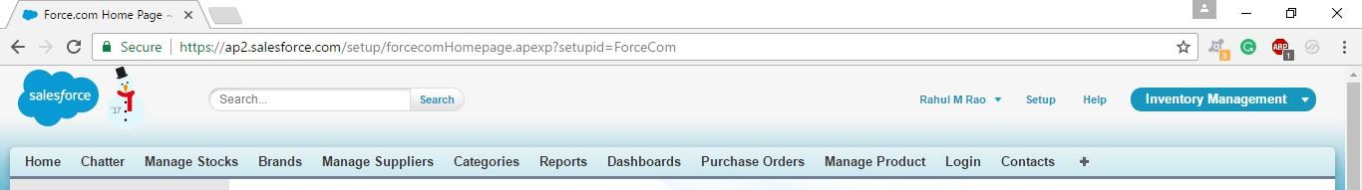

#### Figure 10: Salesforce Home Page

After the Setup button in the header, we can see the Help button which will give detail information about anything in this platform and lastly we can see a drop-down list showing Inventory Management, where we can see the list of apps available in this domain. By selecting the Inventory Management app, we can see all the data/ modules related to this app along with some predefined standard data.

##### 3.2.1 Custom Apps

In Salesforce, creating an App is just a point and click away, to create a new app click on Setup and locate Create, then click on Apps and then on New. As simple as shown below, enter the name of the app as Inventory Management after clicking New.

Setup 🡪 Create 🡪 Apps 🡪 New

Salesforce provides some predefined apps like sales which consist of standard objects and standard fields. Now, we are creating our custom app which will consist of custom objects and custom fields to hold the data.

##### 3.2.2 Objects

Objects in Salesforce are database tables with information. The primary object in the Salesforce data model represents accounts/companies and organizations involved in the business, such as customers, partners, and competitors. A record is similar to a row in a database table.

Objects already created by Salesforce are called standard objects. Objects we create in organization are called custom objects

Created the custom object Brands in the following way,

* Click on Create 🡪 Objects 🡪 Custom Object.
* Enter the Label name as Brand, Plural name as Brands which be used as Tab name and Object name as Brand which will be used as API name. By default, the custom objects are stored with __c to access through API.
* Enter the record name Brand Title which is a mandatory field while creating a custom object and select its data type as Text.
* Next, check allow reports, activities and track field history check box fields, which are basically for availing report creation, assigning tasks to the user for a particular Brand record and tracking the history of all field edits and updates.

In similar fashion, For the Inventory Management App, six custom objects were created.

1. Brand: Tracks all the brands of products in Inventory
2. Category: Tracks the categories of products in the Inventory
3. Manage Supplier: Tracks the details of the suppliers of the products.
4. Manage Products: Tracks the records of the products in the Inventory
5. Manage Stock: Tracks the record Stock in the Inventory
6. Purchase Order: Tracks the record of the Purchases at the point of sale.

The objects can be accessed by tabs in salesforce.com and menu items as in the salesforce1 platform which is a mobile platform.

##### 3.2.3 Fields

Salesforce has provided many inbuilt fields called standard fields like “Name,” “Owner,”

“Created By,” “Last Modified By” etc. Every object in Salesforce has a set of standard fields that may be applicable for capturing data for that type of an object.

Salesforce also allows users to create new fields in the system to capture additional information. These fields are called as custom fields. Salesforce supports a variety of datatypes for these fields like Text, Text Area, Rich Text Area, Number, Currency, Boolean, Email, Phone, etc.

Administrators can then configure how these fields should be set (visible/readonly/edit/mandatory).

Created some more custom fields to the object **Brand** in the following way,

• Create 🡪 Objects 🡪 Brand 🡪 Custom Fields & Relationships.

##### 3.2.4 Relationships

The Force.com platform supports two types of parent-child relationships between objects. They are lookup relationships and master-detail relationships. These relationships connect objects with other objects. These both work like a foreign-key relationship in a relational database. These relations are the fields in the Salesforce. We can create them as we create custom fields.

**The lookup relationship** creates a simple relation between two objects. With this relationship field, we can navigate from records in one object to the related records in another object and can create one-to-one and one-to-many relationships. Lookup relationships are appropriate when a relationship between two objects is required in some cases, but not always. In scenarios like to relate multiple parent records to the child record and to reference commonly shared data, such as reference data, a lookup relationship is used. 

**The master-detail relationship** is a powerful relationship which is based on a parent-child relationship. The object on which we create a master-detail relationship is the child, and the other one is the parent or master object which will be referenced as a field in the child object. The sharing settings of the child object can be taken from their master object. In a master-detail relationship, if we delete master object records, child objects also automatically deleted. With the master-detail relationship, we can create a roll-up summary field on parent objects.

Example:

In Figure 11, charity is the master of events object and donation is the child object of events. So with the Master-detail relationship between them, we can see total money raised, in the charity object which is a roll up a summary of the total donations of the events object.

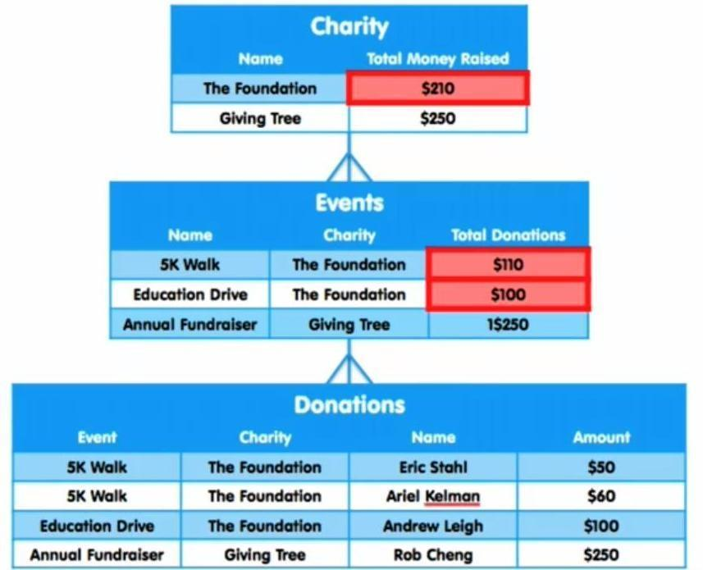

**Figure 11: An example of a Master-Detail relationship**.

In the Inventory Management app, there is a master-detail relationship in between brand and manage product object and in between manage category and manage product objects. The manage product object is the parent of both manage category and brand objects. There is look up the relationship between the delivery order and contact object and then the contact object with a purchase order. The manage the product object have lookup relationship between the purchase order and manage supplier object.

|  |
| --- |
| Look up relationship  Master-detail relationship |

#### Figure 12: Relationships between objects

##### 3.2.5 Tabs

Tabs are the primary way to access the main objects in the application for users in Force.com platform apps. Just like standard objects/fields Salesforce also has the standard/custom tabs. Tabs provide an interface to access records for that particular object. Most standard objects have their tabs exposed. Users can also configure which tabs they would like to see and can rearrange their order. Users can create custom tabs for the custom objects they create. Tabs can also be used to open custom pages and links.

Created a custom Tab to the object **Brand** in the following way,

• Create 🡪 Tabs 🡪 Brands

The Custom Tabs that were created for the custom objects are Brands Tab, Categories Tab, Manage Stocks Tab, Manage Suppliers Tab, Products Tab, Purchase Orders Tab

The other Tabs that are used for visual force Pages Are Login Tab and Manage Product Tab



##### 3.2.6 Securing and Sharing data

Salesforce provides a wide level of security and sharing of data in an organization. Some of them are listed below.

1. Object Level Access: These controls access to objects in the Organization.
2. Field Level Access: These controls access to particular fields in an object.
3. Record Level Access: These controls access to the records of an Object.
4. Profiles: Every user has one profile and this profile is used to control many things like user permissions, object permissions, field permissions, app settings, tab settings, Visualforce page access, Apex class access, page layouts, login hours, and login IP ranges and so on.
5. Permission Sets: Every user can have one profile but can have multiple permission sets. Permission sets to control access of object permissions, field permissions, user permissions, tab settings, app settings and it also controls Apex class access and Visualforce page access.
6. Field Level Permissions: These controls access of a user to view, edit and delete of fields of an object.
7. Organization-Wide Default Settings : These are default controls set by the organization and these controls access to the records of an object.
8. Role Hierarchies: With this, the user who is above in the role hierarchy will have access to the records of their subordinates.
9. Sharing rules: These controls access to the records of an object but these makes exceptions to the organization-wide default.
10. Manual sharing: It overrides the all the restrictions to access the records. One can share records with specific users.

The profile and the user permissions restrict what the user can see. The modifications made in the desktop Salesforce site are reflected in the app even and mobile users to get their Organization's data without special configuration.

##### 3.2.7 Page Layouts

Page Layouts can be used to control the visibility of the custom fields, button and links on the Object record. We can rearrange the fields as per our convenience and by separate sections also. We can make a field to be visible, required or read-only field to control the access for different users, marks few fields as read only, mark few fields as mandatory, et**c**. Page layouts can be created in the following way,

Create 🡪 Objects 🡪 (Custom Object) 🡪 Page Layouts

##### 3.2.8 Visual Force

Visualforce is a complete framework for making such UIs, empowering any interface outline and communication to be constructed and conveyed altogether in the cloud. The UIs that work with Visualforce can expand the standard Force.com stage look and feel, or supplant it with an impressive style and set of sophisticated interactions. Since Visualforce markup is rendered into HTML, designers can utilize Visualforce tags along with standard HTML, JavaScript, Flash, or whatever other code that can execute inside an HTML page on Platform. Visual Force pages can enable in the mobile by just checking the “ enable the page for mobile apps” box field after creating it. With the CSS, the visual force pages can be optimized for the mobile devices and match the look of the Salesforce1. 

For the Inventory Management app, more than 10 VF pages are created. The log in page, the home page, manage the product page, the insert product page, the invoice page and the payment page, are some of them.

##### 3.2.9 Apex

Salesforce introduced Apex as the first cloud computing programming language. The syntax of Apex is quite similar to Java. It is particularly intended for building business applications to oversee Data and procedures larger ambiance of the Force.com platform. The Apex lets the developers focus just on elements specific to their application by providing a productive approach to creating functionality and logic, leaving the rest of work for Force.com Platform.

Usually, for every interactive VF page, Apex Class is associated. So more 10 Apex Classes are used in the Application.

##### 3.2.10 Chatter

Chatter is a standard Salesforce functionality which is very useful feed tracking system in Salesforce where users can post to feed, comment on feeds, shares the information, attach files and share. Also, the user can follow other users to get updates from that user. The user can follow a particular field of an object and can get updates whenever its value changed or updated. It reduces the mailing efforts for a user to update about things going on the organization. Also, create groups who are working on an assignment and keep an update or follow up with them by enabling chatter. It’s like a social network application for the work environment to connect people with updates going in their organization.

##### 3.2.11 Reports and Dashboards

As we know a company deals with lots of data, to check the data record by record is a very lengthy and time taking process. A good application should provide the overview of the data at a glance. For this purpose, Salesforce provided a tool called Reports. Using reports, we can generate different formats of data resides in the company at a glance view. A dashboard is a place where we can put all reports together to give the overview of the statistics. For example, if the manager wants to know how many products are sold from the inventory, he can create reports and find these statistics. Salesforce supports four different formats of Reports which are,

* Tabular Reports: These give a simple list view of data with Grand totals. But these are not used to create groups of data and graphs.
* Summary Reports: These give the summary of the data like subtotals with row-wise also. These are used to create charts, graphs. These reports can be used in the dashboard.
* Matrix Reports: These give the groups of data both by row wise and column wise. These are the most time consuming to generate a report or to set up, but can also be used in the dashboard.
* Joined Reports: These allow to join the multiple reports of different types. These reports can also be used to create charts so that can be used in dashboards.

The Reports can be created as follows,

Create 🡪 Apps 🡪 Add Reports Tab 🡪 Reports.

A Dashboard can show the reports in a visual format like Charts, Gauges, Tables, Metrics, or Visualforce pages. Force.com platform supports 20 components to be allowed in a dashboard for an organization. For example, the reports which we created before, like Pie chart and Vertical bar chart we can put up to 20 components in a dashboard. For the dashboard also we created a folder and saved all the dashboards under Inventory Dashboards folder and shared same as Reports folder. Dashboard can be created as,

Reports Tab 🡪Reports & Dashboards 🡪 New Dashboard

## Chapter 4: The Functionality of Inventory Management

The Inventory Management Application can be divided into two parts i.e.

1. Inventory Administration
2. Point of Sale or Customer Portal

**4.1 Inventory Administration**

Inventory administration is carried out usually by store manager or store admin.

### Schema

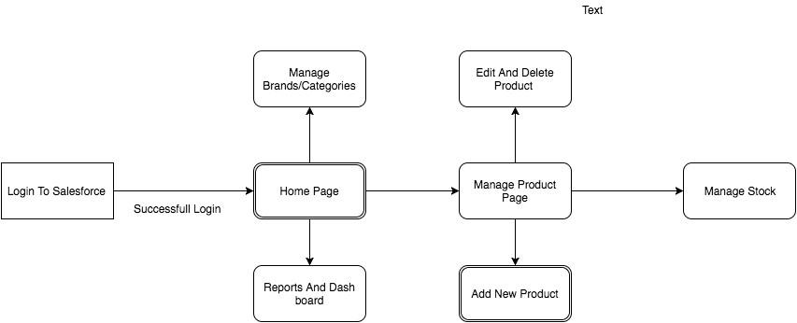

### Figure 13: Schema of Inventory Administrator

The Manager can do the following functions.

The Store Manager can add, edit, delete and view the products in the database. The various functions that a manager can do include updating new brands and suppliers, generating reports (based on the category, brand, created date) and the access to see and edit the customer details and all purchase orders details.

To administrate his inventory, Manager needs to log into Salesforce with his credentials.

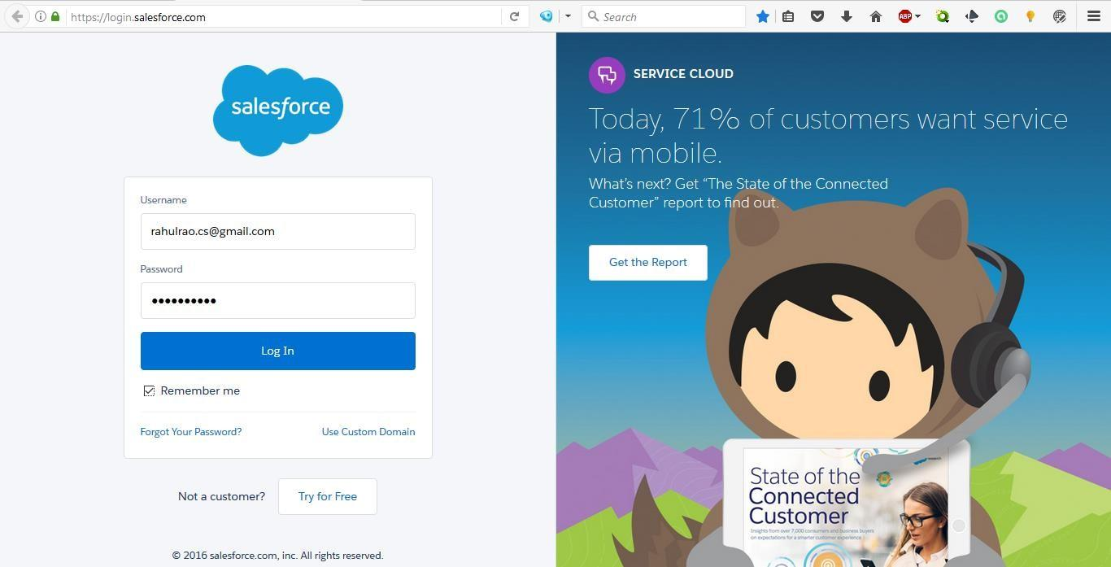

Once the admin logs into the Salesforce, the log in page is redirected to home page. In the home page, the manager finds Standard Page components like apps, tabs, menu and he will also find custom modules like calendar, task to perform, etc., In the home page, the manager can navigate between all the tabs, existing applications, and other components.

Home Page can be customized depending on the requirements. The layout of the page is fixed while the components like tabs can be customized. In the inventory management app, home page is customized.

In the customized home page, manager can view

1. Calendar,
2. Tasks to perform,
3. Dashboards
4. Record need his approval
5. Recent Activities

In addition to standard page components like Tabs, Apps, etc.

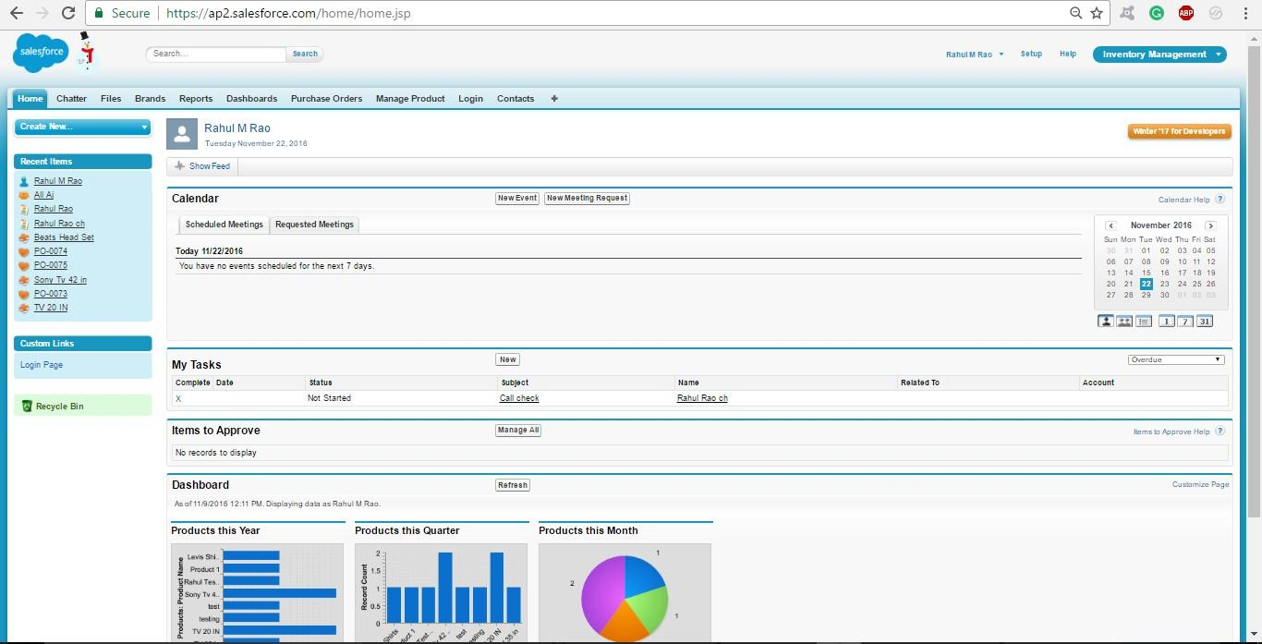

Brands tab has the database of product inventory tagged under various brands. The manager has access to create, delete and view the brands available in inventory. The feature to arrange the brands by filters like recently viewed, recently created and recently modified is also available.

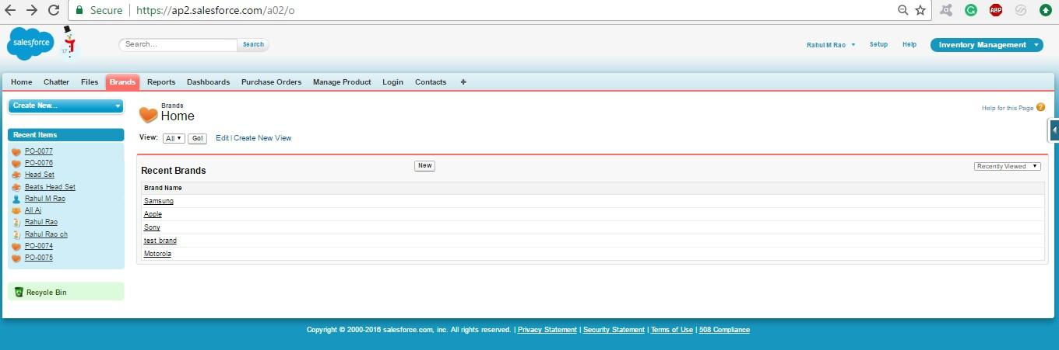

Similarly, the categories tab has provision to create, view and delete the categories of products. The sorting filters like recently viewed, recently created and recently modified can be used for sorting of categories.

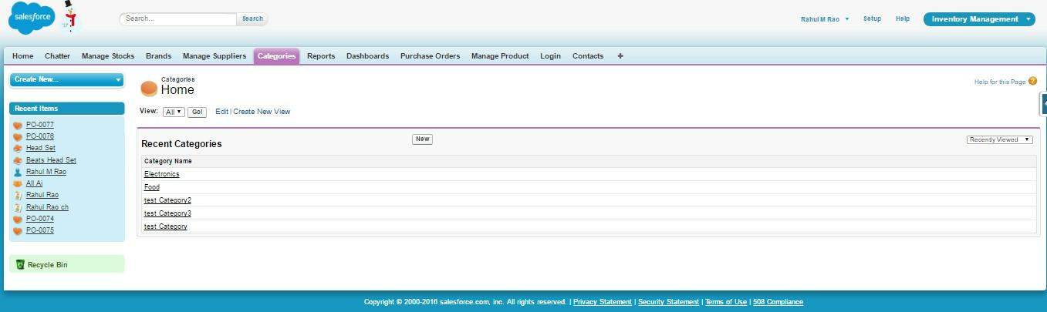

The manage suppliers tab has access to add, view and delete the suppliers for products. Sorting filters like recently viewed recently created and recently modified are provided for this tab also.

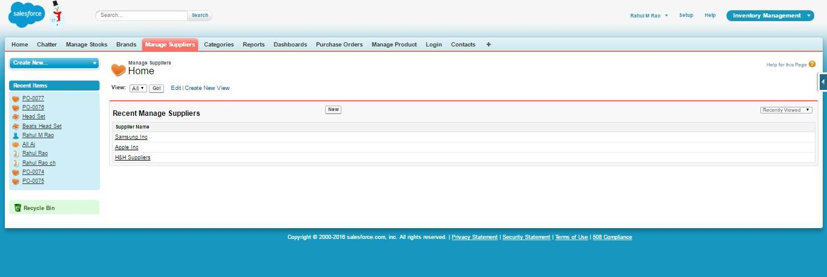

Similar to above features, the manage product tab provides access to store manager on products in the database. Stocks can be viewed and managed in this page.

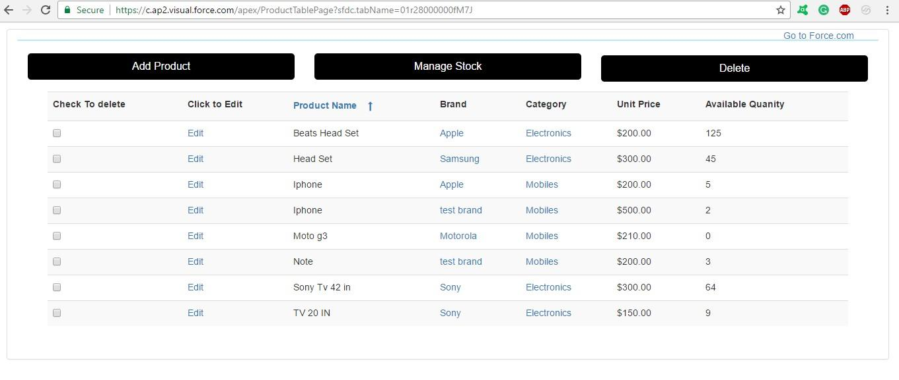

The store manager can add new products based on category, brand, and supplier. Other attributes like the quantity of the product, the unit price and the supplier price of the product are even added to the new product.

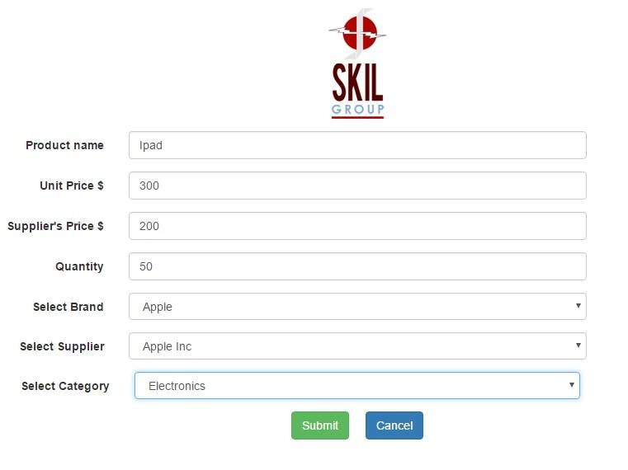

Only the store manager has master access to the database. Input fed by employees is only reflected in the inventory database on approval from a manager. The employee has to raise an approval request.

Salesforce App 1 View:



The Manager can reject or approve a product. If he approves the product, it is reflected in the stock.

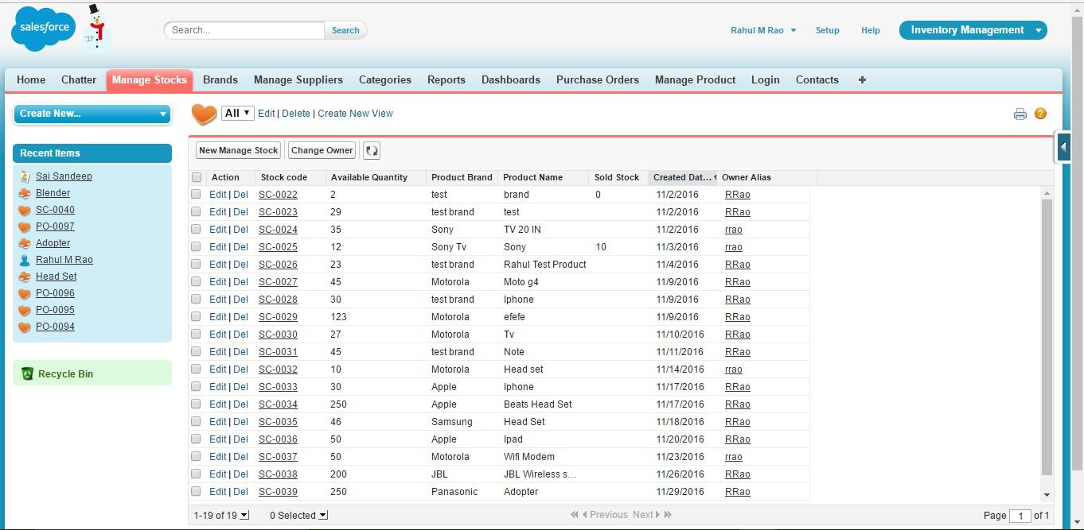

### Approval Process

Every product must get the approval of store manager before it goes into the inventory. Below is the approval process flow.

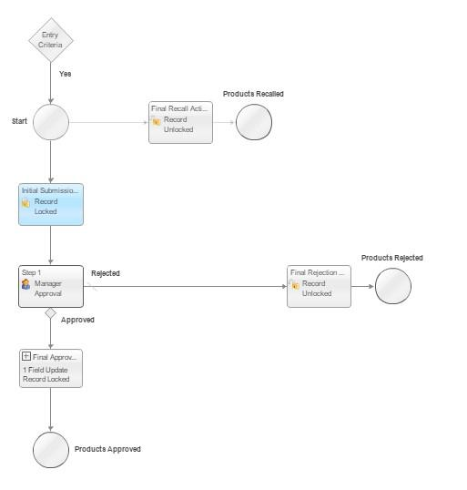

### Figure 14: Product Approval Process

The store manager can generate reports based on

* Categories • Brands • Time.
* Products sold

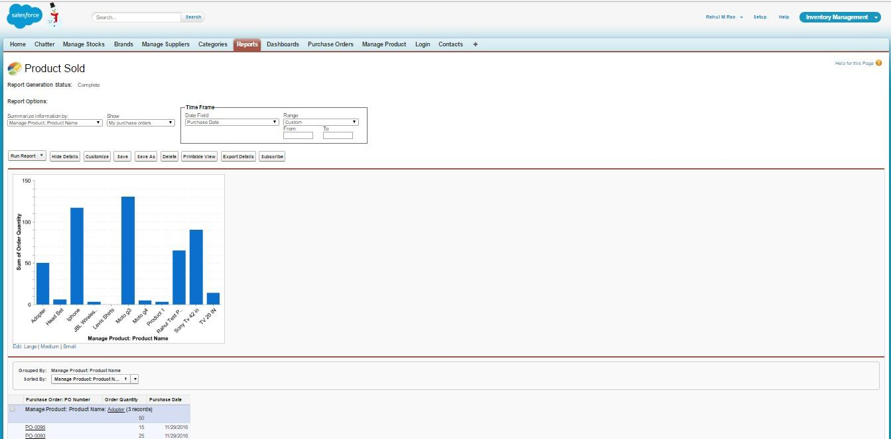

Data Generated from the reports can be viewed in dashboards in formats like

* Horizontal bar chart
* Vertical bar chart
* Line chart
* Pie chart
* Donut chart and
* Funnel chart

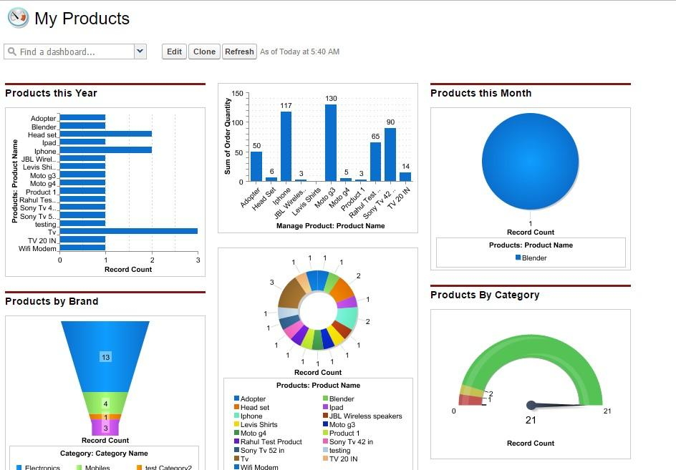

### 4.2 Customer Portal

The customer can perform following functionalities.

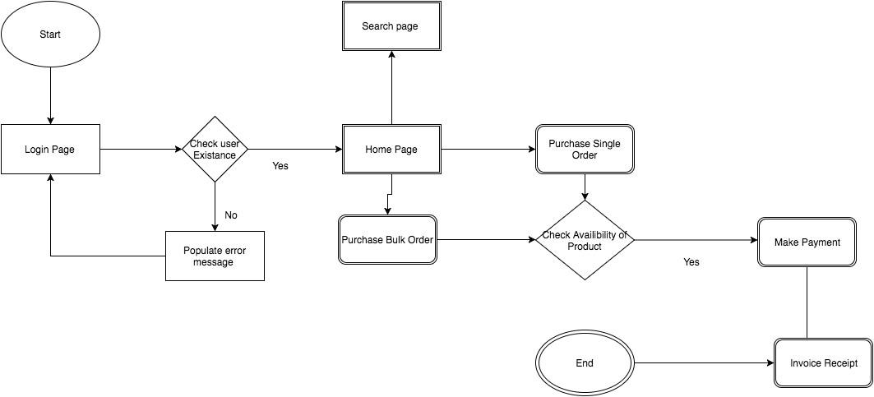

### Figure 15: Workflow of Customer Portal

The customer needs to log in into the Salesforce. A new customer has to register with valid email id, full name, and security questions to get access to the user portal.

### Registration Page

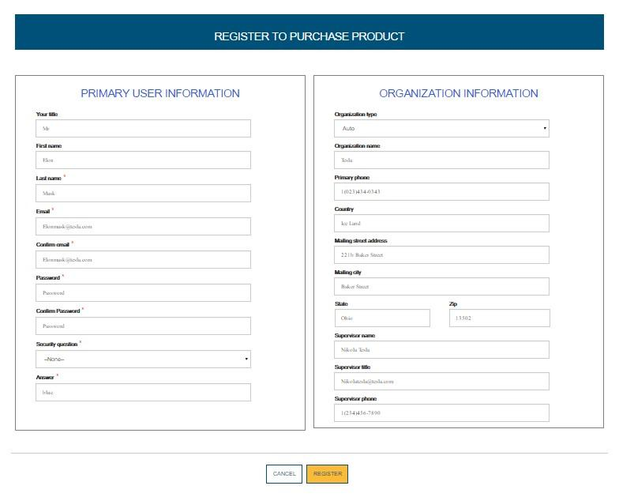

On successful registration, the new user receives a mail from the admin confirming his registration, from when access is available.

### Registration Confirmation Email

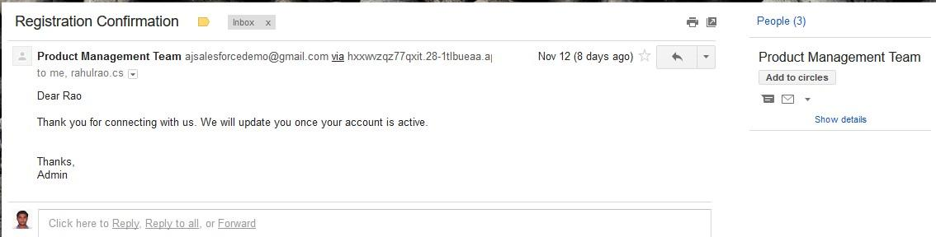

### Login Page

On confirmation of approval from the admin/store manager, the user can now login in into the portal.

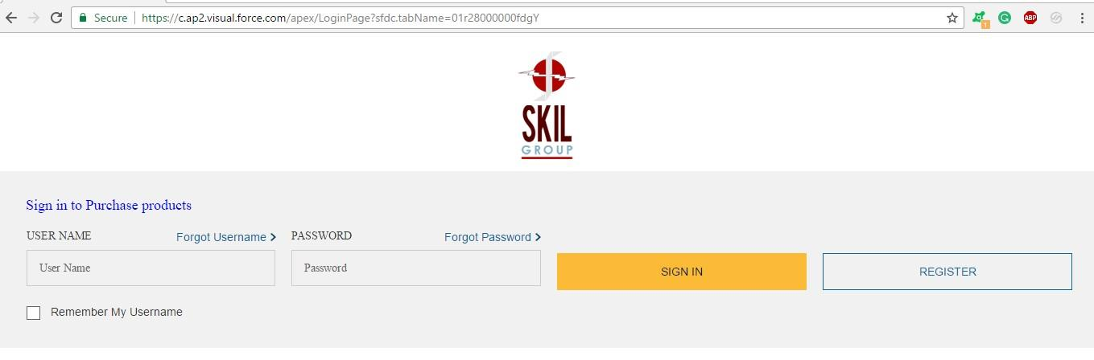

### Forgot Username

‘Forgot Username’ icon is available for the user to retrieve username through registered email address if they do not remember the current user name.

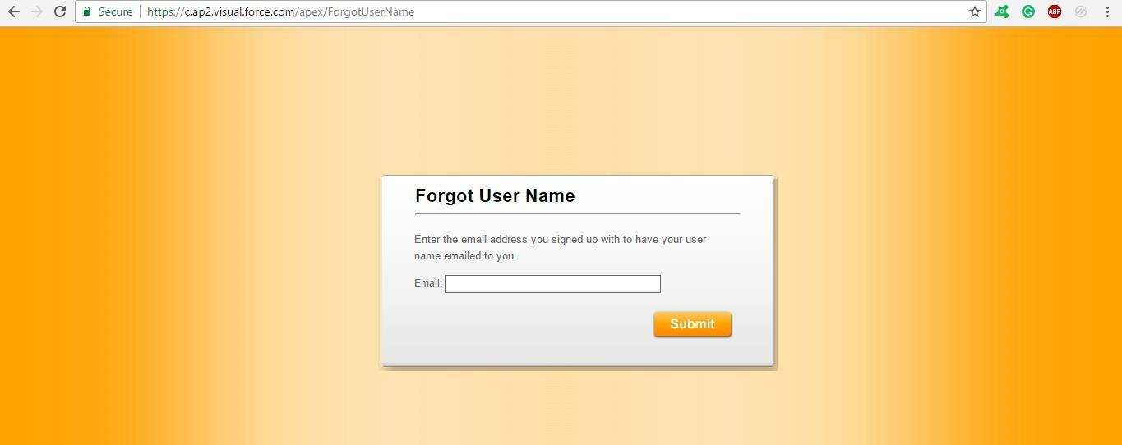

The request mail would only be sent if the email address provided by the user matches with the registered email address, available in the database.

### Forgot Username Email

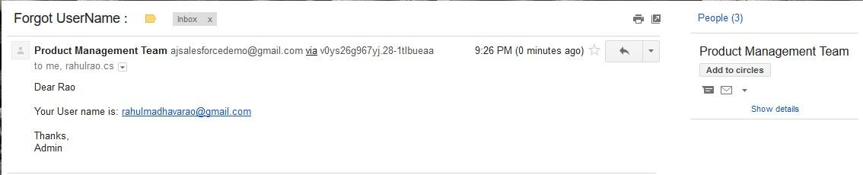

### Forgot Password

The similar process of recovering username is to be followed to ‘Forgot Password’. A link would be sent to a registered email address when the user has to input valid username and answer his security question.

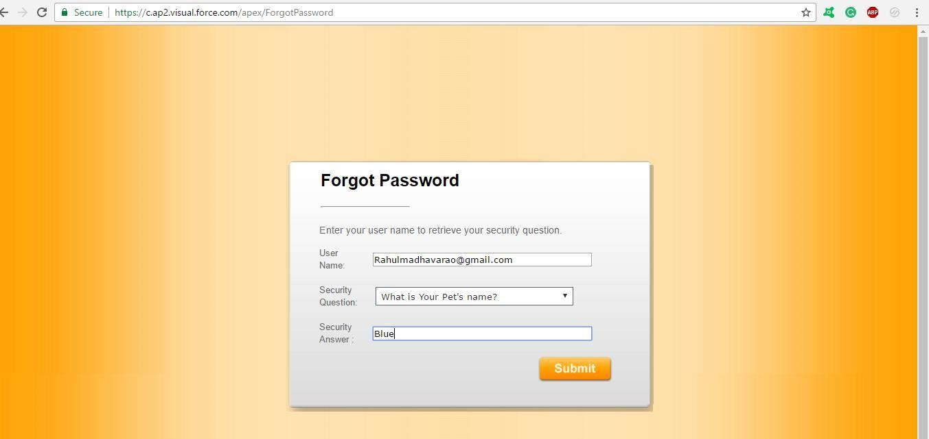

### Forgot Password Confirmation

If the username and security question matches with the data in the database, then he receives a mail with his password

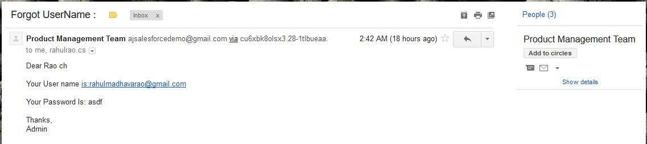

### Homepage

When user signs into the login Page, the login page redirects to the home page where he can search the products in the inventory and then he can purchase the products depending on the quantity

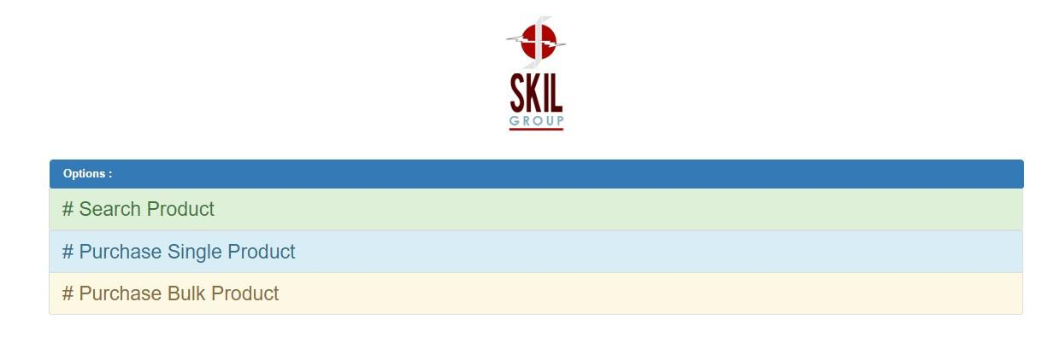

### Search Products

The user can search for products in the inventory based on brand, category and by product name. The available quantity and price of the product are displayed to the user. After selection, the product can be purchased from the home page.

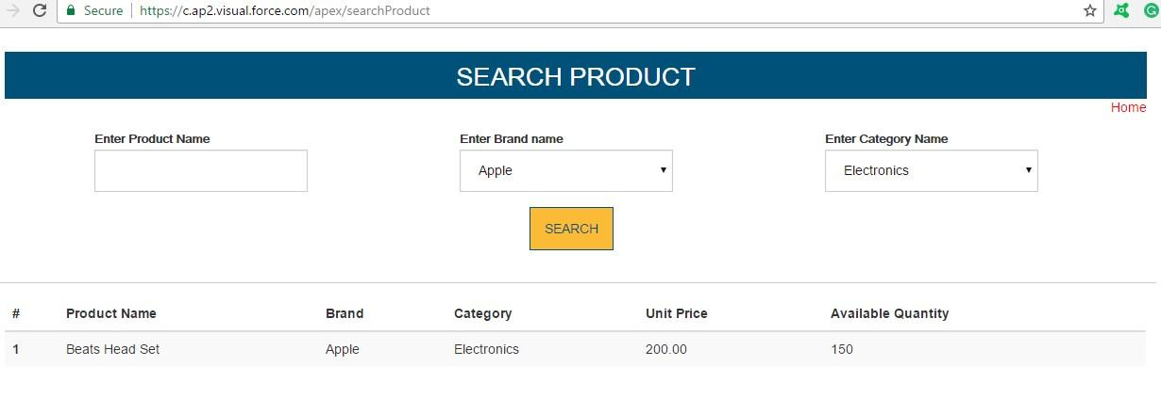

### Single purchase product

The user can continue with purchase options if he is looking for just one product. The quantity of the product can be chosen based on requirement and availability and the purchase can be made using a credit card. After payment, an invoice is generated.

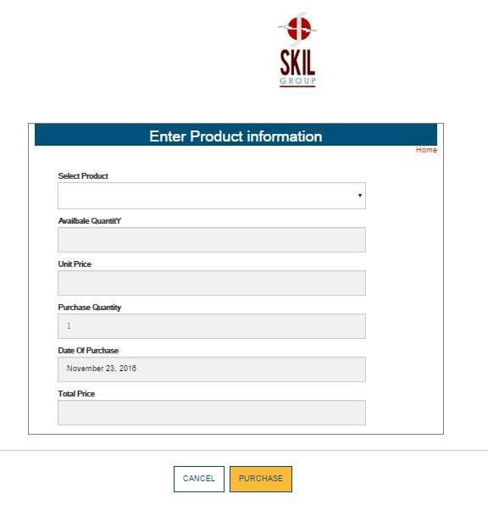

### Bulk Purchase Product

Similarly, if multiple products are to be bought, it can be carried out from Bulk purchase page. The quantity of the product can be chosen based on requirement and availability and the purchase can be made using a credit card. After payment, an invoice is generated.

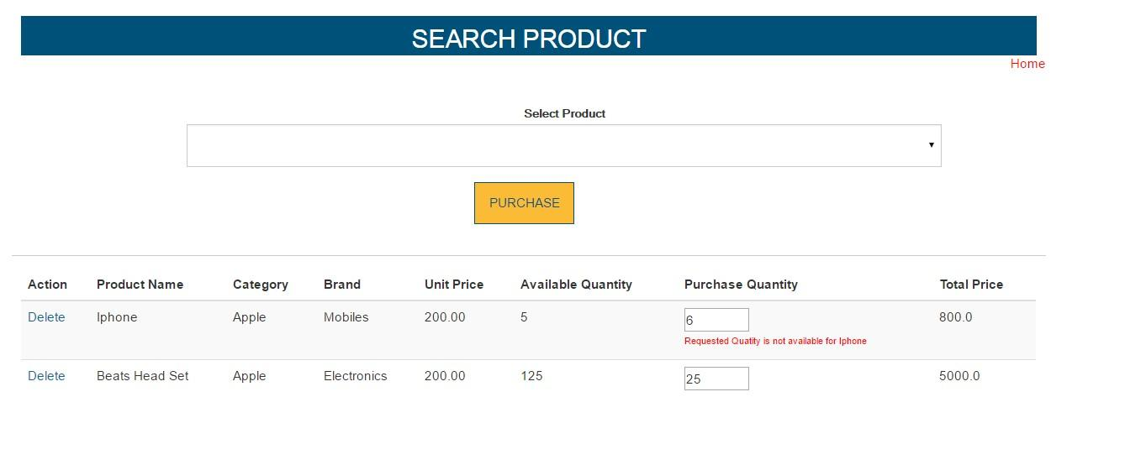

The user can select the product to buy along with the quantity as required. The unit price and the total price for the required quantity are displayed under this tab for convenience. Using credit card details, the items in the cart can be purchased.

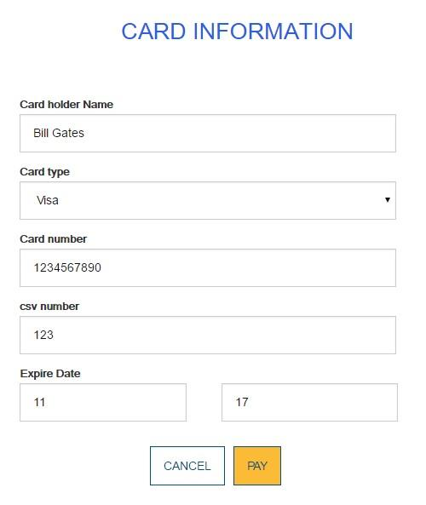

As payment is made, an invoice is generated. The invoice contains the company details like the registered name and address along with customer details such as his full name, his address, followed by the items he purchased, quantities of the items, the unit price of each item and the total price of purchase.

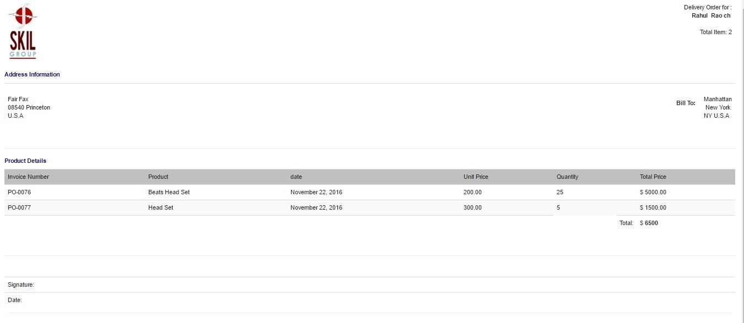

Once the purchase is completed, details are stored in purchase order and the inventory stock is altered and the same in the updated in the inventory stock database.

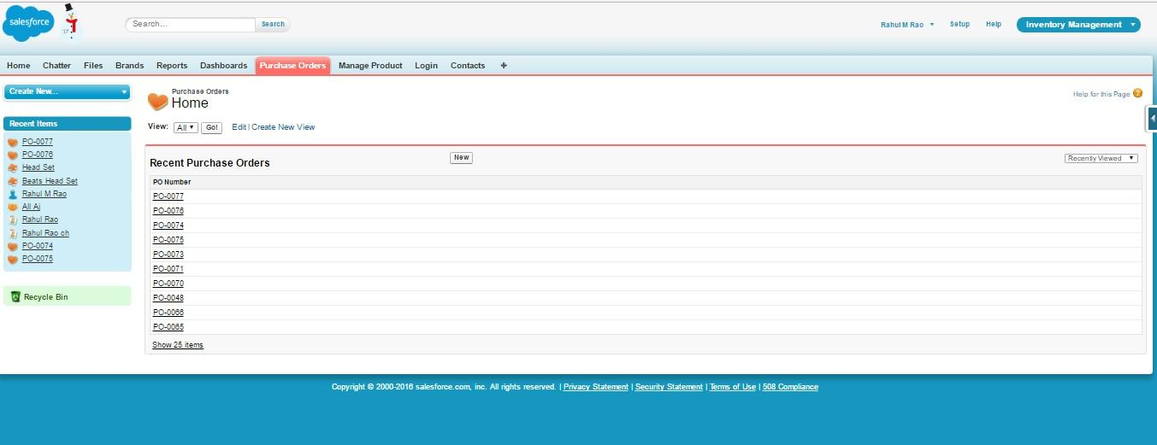

### Appendix

**The code for Visual Force Page of Manage Product is below:**

|  |
| --- |
| <apex:page standardstylesheets="false" standardController="Manage_Product__c" docType="html-5.0" showheader="false" applyHtmlTag="true" extensions="ManageProductController" title="All Product" tabStyle="Manage_Product__c">  <style>  .btnClass { border: 0; outline: none; background: black !important; width: 100%; border-radius: 5px; height: 40px; color: white; margin: 20px 0 0 0; font-size: 16px;  }  </style>  <link rel="stylesheet" href="https://maxcdn.bootstrapcdn.com/bootstrap/3.3.7/css/bootstrap.min.css"  />  <script src="https://ajax.googleapis.com/ajax/libs/jquery/3.1.1/jquery.min.js"></script>  < script src="https://maxcdn.bootstrapcdn.com/bootstrap/3.3.7/js/bootstrap.min.js"></script> <div class="container">  <apex:form styleclass="form-horizontal">  <apex:outputPanel styleClass="myCustomMessage">  <apex:pageMessages ></apex:pageMessages>  </apex:outputPanel>  <div class="form-group ">  <label> &nbsp;</label>  <center>  <apex:image value="{!URLFOR($Resource.ProdImage)}"></apex:image>  </center>  </div>  <div class="form-group">  <label class="col-sm-3 control-label" for="textinput">Product name</label> <div class="col-md-6">  <apex:inputText id="name" value="{!productName}" styleClass="form-control input-md"  />  </div>  </div>  <div class="form-group">  <label class="col-md-3 control-label" for="textinput">Unit Price $</label> <div class="col-md-6">  <apex:inputText id="UPrice" value="{!unitPrice}" styleClass="form-control input-md"  />  </div>  </div>  <div class="form-group">  <label class="col-md-3 control-label" for="textinput">Supplier's Price $</label> <div class="col-md-6"> |
| <apex:inputText id="SPrice" value="{!supplierPrice}" styleClass="form-control input-md"  />  </div>  </div>  <div class="form-group">  <label class="col-md-3 control-label" for="textinput">Quantity</label> <div class="col-md-6">  <apex:inputText id="Squan" value="{!quantity}" styleClass="form-control input-md"/>  </div>  </div>  <div class="form-group">  <label class="col-md-3 control-label" for="textinput">Select Brand</label>  <div class="col-md-6">  <apex:selectList value="{!Brands}" styleClass="form-control input-md" size="1" style="height: 33px;">  <apex:selectOptions value="{!Brand}"></apex:selectOptions>  </apex:selectList>  </div>  </div>  <div class="form-group">  <label class="col-md-3 control-label" for="textinput">Select Supplier</label> <div class="col-md-6">  <apex:selectList value="{!Suppliers}" styleClass="form-control input-md" size="1" style="height: 33px;">  <apex:selectOptions value="{!Supplier}"></apex:selectOptions>  </apex:selectList>  </div>  </div>  <div>  <label class="col-md-3 control-label" for="textinput">Select Category</label> <div class="col-md-6">  <apex:selectList value="{!categories}" styleClass="form-control input-md" size="1" style="height: 33px;">  <apex:selectOptions value="{!Category}"></apex:selectOptions>  </apex:selectList>  </div>  </div>  <div class="form-group">  </div>  <div class="form-actions text-center">  <apex:commandButton value="Submit" action="{!saveProduct}" styleclass="btn btn-success" /> &nbsp;&nbsp;&nbsp;&nbsp;  <apex:commandButton value="Cancel" action="{!CancelProd }" styleclass="btn btn-primary "  />  </div>  </apex:form>  </div>  </apex:page> |

#### The Code for the Manage Product Controller is

|  |
| --- |
| public class ManageProductController {    //variables public String categories {get; set;} public String brands {get;set;} private final Integer COMPARE_INT = 0; public Manage_Product__c manageProdVar {get;set;} public String productName {get;set;} public Integer unitPrice {get;set;} public Integer supplierPrice {get;set;} public String suppliers {get;set;} public Integer quantity {get;set;} private final String NONE_VALUE = '--None--';    //Constructor public ManageProductController(ApexPages.StandardController stdController){    }    //Method to get the list of all Categories public List<SelectOption> getCategory () {  List<SelectOption> options = new List<SelectOption>();  List<Manage_Category__c> categoryList = [SELECT Id,Name  FROM Manage_Category__c];  options.add(new SelectOption(NONE_VALUE, NONE_VALUE)); if(categoryList.size() > COMPARE_INT){ for (Manage_Category__c cat : categoryList) { options.add(new SelectOption(cat.Id, cat.Name));  }  }  return options;  }    //Method to get All brands  public List<SelectOption> getBrand () {  List<SelectOption> options = new List<SelectOption>(); List<Brand__c> brandList = [SELECT Id,Name FROM brand__c]; options.add(new SelectOption(NONE_VALUE, NONE_VALUE)); if(brandList.size() > COMPARE_INT){ for (Brand__c cat : brandList) { options.add(new SelectOption(cat.Id, cat.Name));  }  }  return options;  }    //Method to get All suppliers  public List<SelectOption> getSupplier () {  List<SelectOption> options = new List<SelectOption>();  List<Manage_Supplier__c> supplierList = [SELECT Id,Name FROM Manage_Supplier__c]; options.add(new SelectOption(NONE_VALUE, NONE_VALUE)); if(supplierList.size() > COMPARE_INT){ |

|  |
| --- |
| for (Manage_Supplier__c cat : supplierList) { options.add(new SelectOption(cat.Id, cat.Name));  }  }  return options;  }    //Method to Save Product public PageReference saveProduct () {    manageProdVar = new Manage_Product__c(); if (suppliers != NONE_VALUE) { manageProdVar.Supplier__c = suppliers ;  }  if (categories != NONE_VALUE) { manageProdVar.Category__c = categories ;  }  if (brands != NONE_VALUE) { manageProdVar.Brand__c = brands ;  }    manageProdVar.Unit_Price__c = unitPrice; manageProdVar.Name = productName; manageProdVar.Supplier_s_Price__c = supplierPrice; manageProdVar.Total_quantity__c = quantity;  try {  insert manageProdVar;  } catch (Exception e) {  ApexPages.Message myMsg = new ApexPages.Message(ApexPages.Severity.ERROR, 'error');  }    PageReference pageRef = new PageReference('/'+ manageProdVar.id); pageRef.setRedirect(True);    if(manageProdVar.id == Null){ return null;  }else {  createOrUpdateStockForProduct (manageProdVar.id); return pageRef;  }  }    //Method to Add and update stock Records public void createOrUpdateStockForProduct (Id ProductId) {    List<Manage_Stock__c> listManageStock = [SELECT Id,NAME,Product_Brand__c,Product_Name__c,  Avaiable_Quantity__c FROM Manage_Stock__c  ];    List<Manage_Product__c> productVarList = [SELECT Id,Name,Brand__c,Total_quantity__c,Brand__r.name , Category__c  FROM Manage_Product__c  ];    Manage_Product__c productVar = [SELECT Id,Name,Brand__c,Total_quantity__c ,Brand__r.name , Category__c  FROM Manage_Product__c |
| WHERE Id =: ProductId]; Integer incrementProd = 0;    if (productVarList.size() > COMPARE_INT) { for (Manage_Product__c varProd : productVarList) { if(varProd.Name == productVar.name && productVar.Brand__r.name == productVar.Brand__r.name){ incrementProd += Integer.valueOf(varProd.Total_quantity__c);  }  }  }    Manage_Stock__c stockObj;  Integer incrementQuantity = 0;  List<Manage_Stock__c> ListToupdate = new List<Manage_Stock__c> ();    if (listManageStock.size() > COMPARE_INT) { for (Manage_Stock__c stockVar : listManageStock) { if(stockVar.Product_Name__c == productVar.name && stockVar.Product_Brand__c == productVar.Brand__r.name){ incrementQuantity ++; stockVar.Avaiable_Quantity__c = incrementProd*incrementQuantity; listToupdate.add(stockVar);  }  }  update listToupdate;    if (incrementQuantity == COMPARE_INT) { stockObj = new Manage_Stock__c(); stockObj.Product_Name__c = productVar.name; stockObj.Avaiable_Quantity__c = productVar.Total_quantity__c; stockObj.Product_Brand__c = productVar.Brand__r.name; try{ insert stockObj;  }  Catch(Exception e){  System.debug('Inside maanage Product Controller : Line 143 : error' + e.getMessage());  }    }  }  }    public PageReference CancelProd () {  PageReference pageRef = new PageReference('/apex/ProductTablePage'); pageRef.setRedirect(True); return pageRef;  }  } |

### References

1. <http://www.desynit.com/good-systems-blog/salesforce/why-salesforce/>
2. <http://www.dummies.com/business/customers/why-use-salesforce/>
3. <http://www.investopedia.com/terms/i/inventory-management.asp?lgl=no-infinite>
4. [Extremely effective CRM Solution using Salesforce](http://www.jetir.org/papers/JETIR1405006.pdf)
5. <https://en.wikipedia.org/wiki/Salesforce.com#Technologies>
6. <http://www.salesforce.com/salesforce-advantage/>
7. https://www.coursehero.com/file/p7j1uvo/A-businesss-inventory-is-one-of-its-majorassets-and-represents-an-investment/
8. https://resources.docs.salesforce.com/sfdc/pdf/salesforce_creating_on_demand_apps.pdf
9. <https://en.wikipedia.org/wiki/Cloud_computing>
10. <http://www.pcmag.com/article2/0,2817,2372163,00.asp>
11. Anjaneya, R., & Mettu, R. R. (1970). MY SALESFORCE. Retrieved December 05, 2016, from http://mysalesforcelearners.blogspot.com/

1. <http://intocloud.org/paas-platform-as-a-service/>

1. <http://csc.columbusstate.edu/eckart/classes/cpsc6125/topics/topic_74.shtml>
2. [http://www.termpaperwarehouse.com/essay-on/Enterprise-Resource-Planning-SoftwareOf-The/436284](http://www.termpaperwarehouse.com/essay-on/Enterprise-Resource-Planning-Software-Of-The/436284)